S8. Supplementary Appendix. Details on the model parameters, areas allowed, dispersal probabilities and time stratification schemes for each Control, Pebas&Acre System and Andes.

Control Scenario
Hypothesis (NULL): The geological history of South America did not play an important role in the dispersal and diversification of the family Polythoridae.

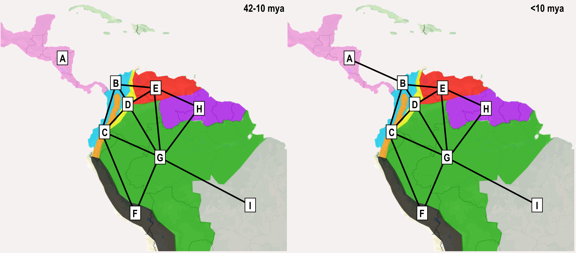
Areas Allowed: Yes (removed impossible from areas adjacency)
Dispersal probabilities: Yes (but all were set to 1)
D and E were free, non J and J models were run.
Time Stratified analysis: Yes, but only accounts for the Isthmus of Panama.

Pebas and Acre Systems Scenario
Hypothesis (A): The geological history of South America did play a crucial role in the dispersal and diversification of the family Polythoridae.
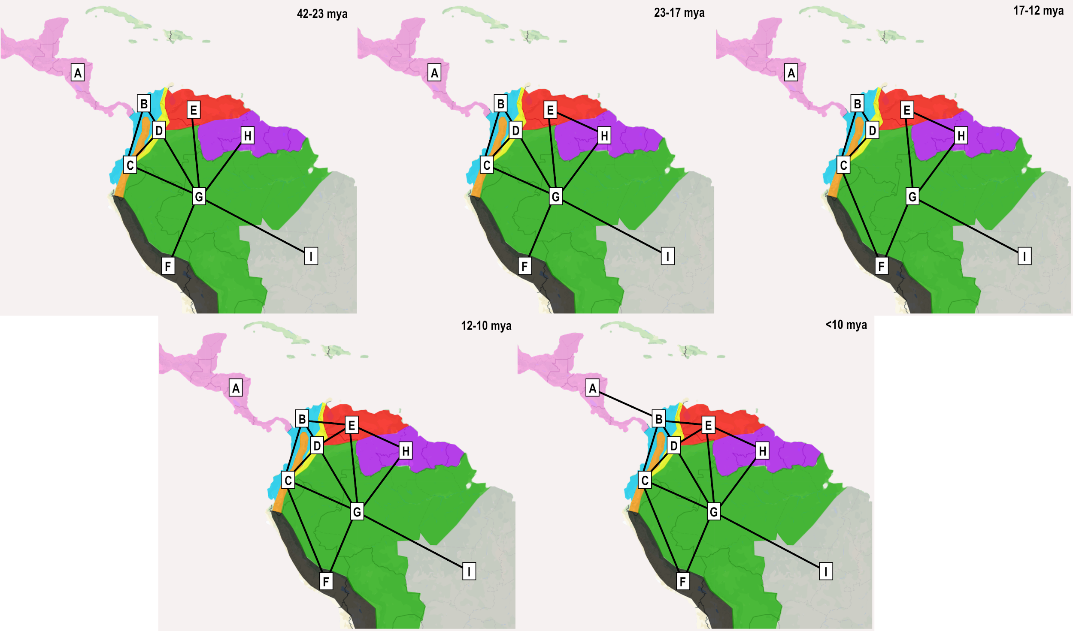
Coded:
Areas Allowed: Yes (removed impossible from areas adjacency, and geological history (Pebas, Acre)
Dispersal probabilities: Yes (but all were set to 1)
D and E were free, non J and J models were run.
Time Stratified analysis: Yes, accounts for the Isthmus of Panama, marine incursions, and Pebas/Acre wetland systems.

Andes Scenario.
Hypothesis: The gradual uplift of the Andean range, combined with the geological history of South America, played a crucial role in the dispersal and diversification of the family Polythoridae.

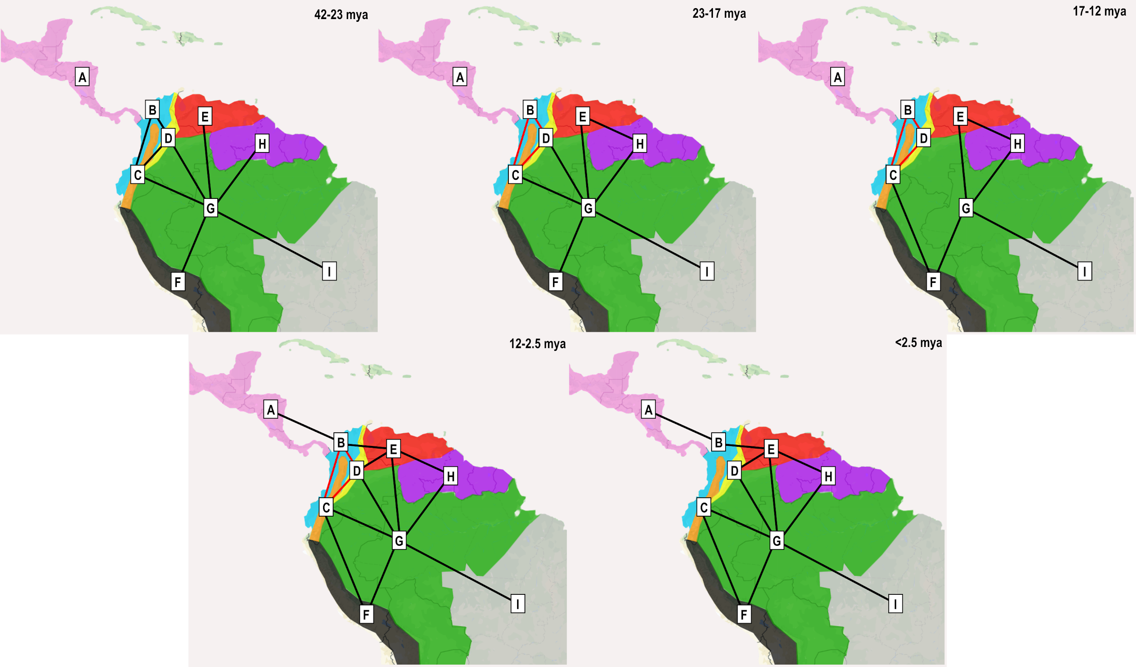
Coded:
Areas Allowed: Yes (removed impossible from areas adjacency, and geological history (Pebas, Acre)
Dispersal probabilities: Yes (Areas with increased Andean uplight had decreased dispersal probabilities)
D and E were free, non J and J models were run.
Time Stratified analysis: Yes, accounts for the Isthmus of Panama, marine incursions, and Pebas/Acre wetland systems, uplift of Andes restricting dispersal.

